Sponsorship Levels

Title Sponsor! - ($2,500 +)
- Name on all promotional items. “(Company Name) Blue Jeans & Bling Fundraiser, benefiting HorsePower”.
- Receives a reserved VIP table for (8) with Company Logo
- Recognition announcement during the Event
- Signage recognition on event poster
- Name on Eventbrite and Facebook event page
- Social media recognition, including a link to your website

The Triple Crown ($1,250.00 - $2,400.00)
- Receives a reserved table for (8) with Company Logo
- Signage recognition on event poster
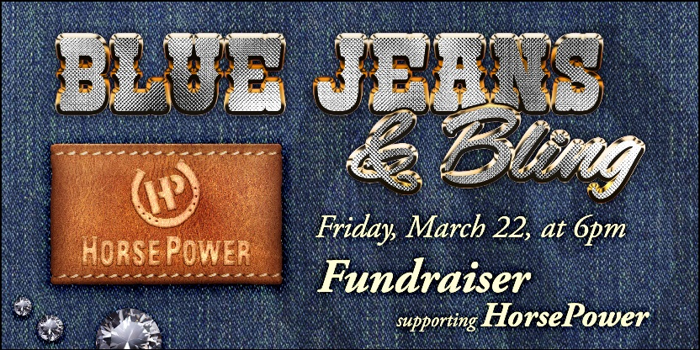
- Name on Eventbrite and Facebook event page

The Kentucky Derby ($750.00 – 1,249.00)
- Signage recognition on event poster
- Name on Eventbrite and Facebook event page
- (4) tickets to Blue Jeans & Bling

The Belmont Stakes $250 – $749.00)
- Signage recognition at the event
- Name on Eventbrite and Facebook event page

Sponsor Information

Name of Business/Individual ________________________________________________________

Name of Contact (if business) _______________________________________________________

Mailing Address ___________________________________________________________________

City _______________________________ State ___________________ Zip Code _____________

Telephone ________________________________ Fax ____________________________________

Email ____________________________________

Please list in publication as _________________________________________________________
Payment Options
_________ Check Enclosed (please make checks payable to HorsePower)
_________ Credit Card (please call information to Jamie (office administrator) at 605-251-1685

Please return form to:
HorsePower of Sioux Falls
26659 Blue Sage Lane, Ste 100
Sioux Falls, SD 57106

HorsePower of Sioux Falls is a registered 501(c) (3) organization. All gifts are tax deductible to the extent allowed by law.

